Purpose:
The task is to calculate the drag force of coffee filters of which are different masses. The group must also perform this task by designing their own experiment.
Equipment:
5 coffee filters, 1 triple scale balance, 1 motion detector, 1 2 to 3 inch level, 1 calculator, 1 TI-84 Calculator, 1 computer, 1 pencil, the correct connecting cords that connect the motion detector to the computer while the motion detector is still in use, 2 bars of about 3 feet with a cross bracket,
Procedure:
To begin, the one person from the group will measure the weight of the coffee filters. He or she will begin with one and then record the mass. He or she will continue to add one single filter at a time and record the mass until he or she reaches five filters.
Next, another member of the group will set up the cross bars, so that the motion detect may attach while hanging far enough off a table so that it does not pick up unwanted objects while scanning. After this is completed, hook up the motion detector to the TI-84 and set up the program to retrieve the data from the trials.
Another member will hold one filter for the first run up under the motion detector with two fingers directly centered holding either side of the filter. Yet another person shall tell the filter holder to release the filter when he or she runs the program to retrieve the data of time versus distances as the filter falls. After each trial the data shall be moved to a computer program to analyze the data and retrieve a graph of it also. This process shall be repeated after one filter is added after every trial until we reach five.
Once the trials are completed, a member of the group must analyze the data from an acceptable point on the graph and take the average. This slope multiplied by gravity (9.81) shall give you the drag force according to the appropriate drag formula. You may then graph the drag forces according to the terminal velocity and compare how the mass of the filter affects how fast they fall against air resistance.

Data and Analysis:
 | First Run
 | m = .0018kg |  |  | Time (s) |  | Distance (m) |  |  |  |  | Distance (m) vs. Time (sec)
 |  |  |  | 0 |  | 0.15549
 | Drag= .0176 |  |  | 0.01 |  | 0.15743
 |  |  |  | 0.02 |  | 0.16548
 |  |  |  | 0.03 |  | 0.16743
 |  |  |  | 0.04 |  | 0.17576
 |  |  |  | 0.05 |  | 0.18048
 |  |  |  | 0.06 |  | 0.18492
 |  |  |  | 0.07 |  | 0.19186
 |  |  |  | 0.08 |  | 0.19686
 |  |  |  | 0.09 |  | 0.19547
 |  |  |  | 0.1 |  | 0.20436
 |  |  |  | 0.11 |  | 0.20686
 |  |  |  | 0.12 |  | 0.21824
 |  |  |  | 0.13 |  | 0.22435
 |  |  |  | 0.14 |  | 0.23073
 | Second Run
 | m = .0036kg |  |  | Time (s) |  | Distance (m)
 |  |  |  | 0.38 |  | 0.67304
 | Drag = .0353 |  |  | 0.39 |  | 0.67915
 |  |  |  | 0.4 |  | 0.68915
 |  |  |  | 0.41 |  | 0.69942
 |  |  |  | 0.42 |  | 0.71497
 |  |  |  | 0.43 |  | 0.71858
 |  |  |  | 0.44 |  | 0.74218
 |  |  |  | 0.45 |  | 0.76439
 |  |  |  | 0.46 |  | 0.7655
 |  |  |  | 0.47 |  | 0.77217
 |  |  |  | 0.48 |  | 0.78772
 |  |  |  | 0.49 |  | 0.79355
 |  |  |  | 0.5 |  | 0.80493
 |  |  |  | 0.51 |  | 0.81604
 |  |  |  | 0.52 |  | 0.84242
 |  |  |  | 0.53 |  | 0.83825
 |  |  |  | 0.54 |  | 0.85297
 |  |  |  | 0.55 |  | 0.86074
 |  |  |  | 0.56 |  | 0.86602
 |  |  |  | 0.57 |  | 0.88045
 |  |  |  | 0.58 |  | 0.88962
 |  |  |  | 0.59 |  | 0.90045
 |  |  |  | 0.6 |  | 0.91155
 |  |  |  | 0.61 |  | 0.91933
 |  |  |  | 0.62 |  | 0.93238
 |  |  |  | 0.63 |  | 0.93626
 |  |  |  | 0.64 |  | 0.9507
 |  |  |  | 0.65 |  | 0.96958
 |  |  |  | 0.66 |  | 0.97764
 |  |  |  | 0.67 |  | 0.99318
 |  |  |  | 0.68 |  | 1.01207
 |  |  |  | 0.69 |  | 1.01679
 |  |  |  | 0.7 |  | 1.02817
 |  |  |  | 0.71 |  | 1.04289
 |  |  |  | 0.72 |  | 1.05066
 |  |  |  | 0.73 |  | 1.05788
 |  |  |  | 0.74 |  | 1.06871
 |  |  |  | 0.75 |  | 1.0837
 |  |  |  | 0.76 |  | 1.09286
 |  |  |  | 0.77 |  | 1.10286
 | Third Run |  |  | Time (s) |  | Distance (m)
 | m = .0052kg |  | 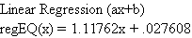  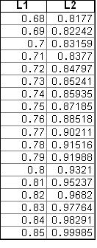  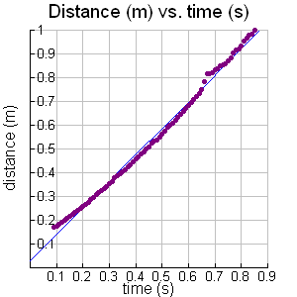
 | Drag= .0510
 | Fourth Run |  |  | Time(s) |  | Distance (m)
 | m = .0069kg |  |  | 0.03 |  | 0.151046 |  |  |  | 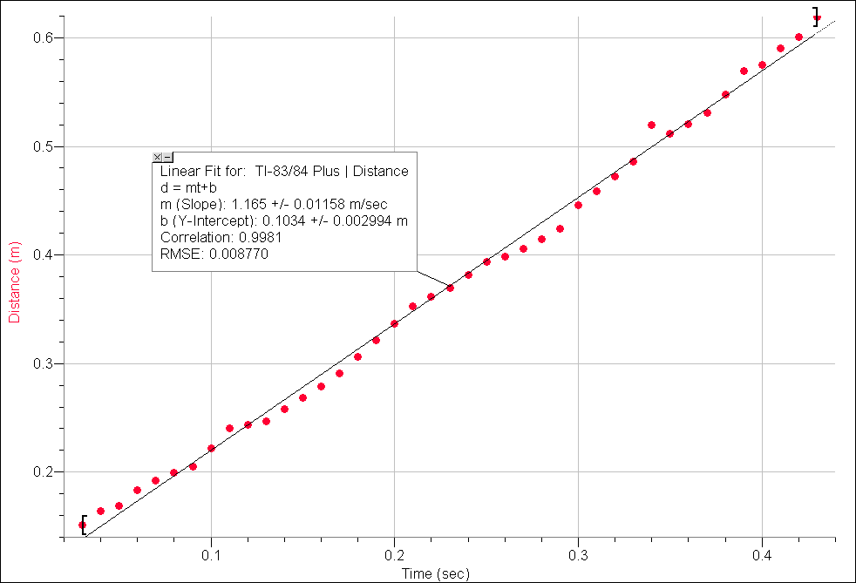
 |  |  |  | 0.04 |  | 0.163818
 | drag = .0676 |  |  | 0.05 |  | 0.168816
 |  |  |  | 0.06 |  | 0.183255
 |  |  |  | 0.07 |  | 0.19214
 |  |  |  | 0.08 |  | 0.199636
 |  |  |  | 0.09 |  | 0.20519
 |  |  |  | 0.1 |  | 0.221849
 |  |  |  | 0.11 |  | 0.240175
 |  |  |  | 0.12 |  | 0.243784
 |  |  |  | 0.13 |  | 0.247116
 |  |  |  | 0.14 |  | 0.257945
 |  |  |  | 0.15 |  | 0.268218
 |  |  |  | 0.16 |  | 0.278769
 |  |  |  | 0.17 |  | 0.290986
 |  |  |  | 0.18 |  | 0.30598
 |  |  |  | 0.19 |  | 0.321806
 |  |  |  | 0.2 |  | 0.3368
 |  |  |  | 0.21 |  | 0.352349
 |  |  |  | 0.22 |  | 0.361234
 |  |  |  | 0.23 |  | 0.369563
 |  |  |  | 0.24 |  | 0.38178
 |  |  |  | 0.25 |  | 0.393442
 |  |  |  | 0.26 |  | 0.39844
 |  |  |  | 0.27 |  | 0.405937
 |  |  |  | 0.28 |  | 0.414544
 |  |  |  | 0.29 |  | 0.423984
 |  |  |  | 0.3 |  | 0.445642
 |  |  |  | 0.31 |  | 0.458969
 |  |  |  | 0.32 |  | 0.472019
 |  |  |  | 0.33 |  | 0.485902
 |  |  |  | 0.34 |  | 0.519499
 |  |  |  | 0.35 |  | 0.511447
 |  |  |  | 0.36 |  | 0.520332
 |  |  |  | 0.37 |  | 0.530883
 |  |  |  | 0.38 |  | 0.54782
 |  |  |  | 0.39 |  | 0.569477
 |  |  |  | 0.4 |  | 0.575031
 |  |  |  | 0.41 |  | 0.590302
 |  |  |  | 0.42 |  | 0.600853
 |  |  |  | 0.43 |  | 0.619178
 | 5th Run |  |  | Time(s) |  | Distance (m)
 | m= .0089kg |  |  | 0 |  | 0.182422
 |  |  |  | 0.01 |  | 0.195472 |  |  |  | 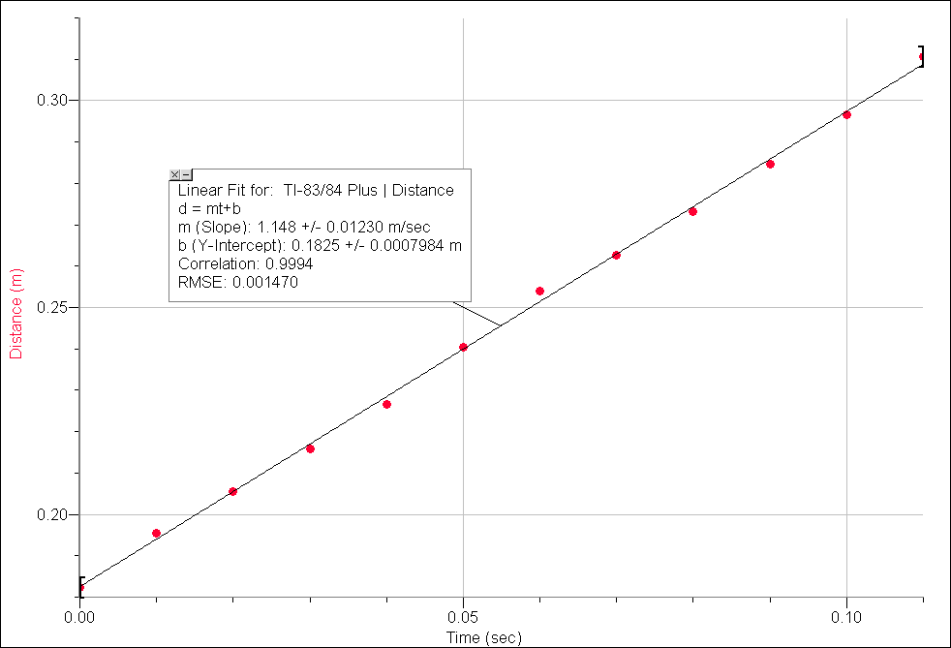
 | Drag= .0872 |  |  | 0.02 |  | 0.205467
 |  |  |  | 0.03 |  | 0.215741
 |  |  |  | 0.04 |  | 0.226569
 |  |  |  | 0.05 |  | 0.240452
 |  |  |  | 0.06 |  | 0.254057
 |  |  |  | 0.07 |  | 0.262665
 |  |  |  | 0.08 |  | 0.273216
 |  |  |  | 0.09 |  | 0.2846
 |  |  |  | 0.1 |  | 0.296539
 |  |  |  | 0.11 |  | 0.3107
 |  | V (m/s)  0.5277  1.1079  1.11762  1.165  1.148  Drag force(N)  0.01764  0.03528  0.05096  0.06762  0.08722 |  |  |  |  |  |  | 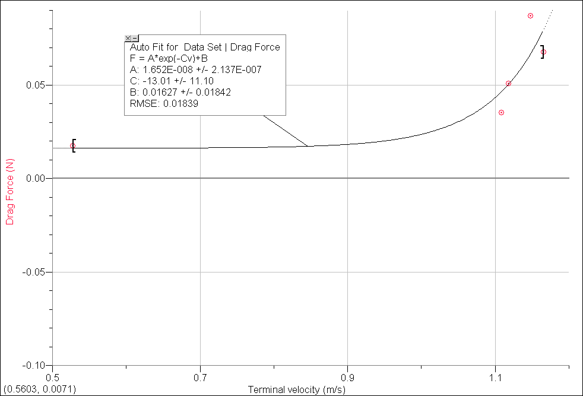
Conclusion:
According the graph analysis of the terminal velocity against the drag force of the coffee filters, I am able to conclude that with increasing mass there is also increasing drag force.

